Directions for use:
Black: Narration and title graphics
Blue: English original or English voice-over-translations (below each translation, a transcript of the Assamese original is to be found)
Red: Transcription of Hindi original (solely page 7)

00:21
TITLE GRAPHIC: Asia – Secret Lives, Hidden Places

00:27
A mighty river
that feeds a land of riches…

00:36
…where the soul of the Indian sub-continent meets the wilderness.

00:45
TITLE GRAPHIC: INDIA

00:47
TITLE GRAPHIC: Where Wild Things Roam

00:53
Morning mists lie thick during winter in Kaziranga National Park.

00:59
Kaziranga is a World Heritage Site, home to Asia’s big five of wildlife…all of them endangered. The Indian One-horned Rhinoceros
The Eastern Swamp deer
Over 1000 Asian Elephants

01:18
The world’s largest density of Bengal tigers

01:23
and the Wild Asian Water Buffalo.

01:27
Kaziranga is a green refuge below the Himalayas. But the wild animals don’t always stay in this haven, and the humans won’t stay out. This is the story of what happens when they cross each other’s borders.

01:44
The Brahmaputra River forms the park’s entire northern border – its dynamic currents build sand islands where rich grasses grow. On Shapori Island, people have grazed their herds since before the area became protected in 1905.

02:06
Oikay Kutum is a second generation herder. He lives directly opposite the
Kaziranga wetlands.

02:14
OIKAY KUTUM
Sometimes tigers come over to the island, but that’s not a problem.
Now and then a cow is killed and we go search for the carcass.
We don’t have any objections. Tigers need food. They are hunters. Humans are scared of the tiger, but the tiger is more scared of us.
We see their footprints but not the tigers.
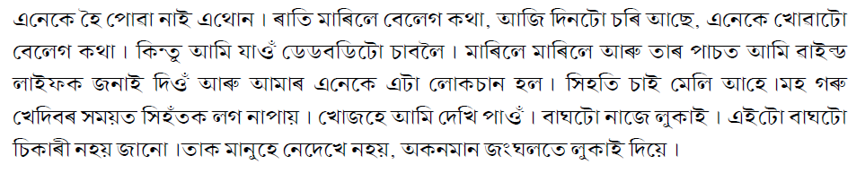
02:51
OIKAY KUTUM
Some people have fear but I don’t .
I always stay near my cattle. I feel lonely if I don’t.
03:07
Oikay Kutum wants some of the wild animals of Kaziranga to visit his farm. That’s why he stays on Shapori. He lives in an extraordinary part of the world - in north-east India, in the state of Assam near the international border with China. Kaziranga National Park covers 430 square km’s of the Brahmaputra floodplain. One day Shapori island may also become part of the park. Until then, Oikay Katum will carry on his unusual traditions.

03:46
Every morning, an agent collects fresh milk right from the hut door to deliver direct to hotels. In all of Assam there is nothing as good as the milk Oikay’s buffaloes produce. Because it comes from the offspring of the rare wild Asian water buffalo.

04:05
OIKAY KUTUM
My domestic buffalo always mate with the wild male buffaloes from the park. So all the calves have the wild genes. Even so, they get used to humans.
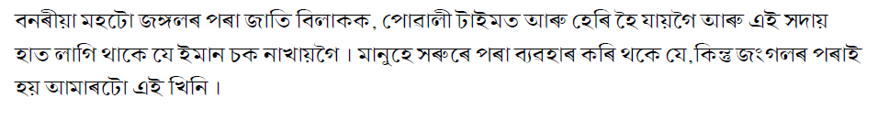

04:21
But their father’s never will – and they are dangerous. The wild Asian water buffalo has the biggest horns of any living bovine and weighs in at over a tonne. The adult males are extremely territorial.

04:37
OIKAY KUTUM
We can’t keep our young male calves because wild buffaloes will swim over to the island and gore all them.
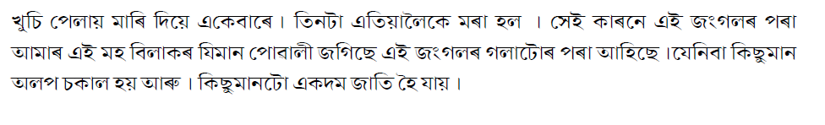
04:47
OIKAY KUTUM
Wild bulls have already killed three young calves this year.

04:51
This young male doesn’t want to leave, but for his own sake, and for the sake of all the livestock on the island, he must. By the end of today, he’ll be on his way to the mainland.
05:05
Livestock herders must be extremely vigilant right now. Some of the domestic cattle on the island have recently given birth. And one of Oikay’s cows is due to have her calf any day. The last thing he needs is a jealous wild buffalo swimming over from Kaziranga.

05:29
Kaziranga National Park, has over 70% of the world’s wild population of Indian One Horned Rhinoceros. Saving the Rhino from extinction is the reason why the area was made a reserve over a century ago. Since then they have increased in number, but still they are not safe.
This is Uttam Saikia, he’s a journalist and an honorary wildlife warden.
He grew up near Kaziranga, and has a strong connection to the rhino and the Park.

06:03
UTTAM SAIKIA
Kaziranga is like an open university. I learn new things every day here, things like the value of life and my responsibility to the wildlife of Kaziranga.
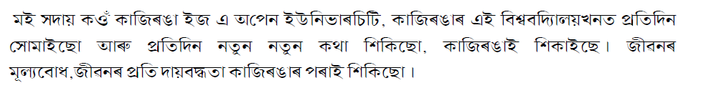
06:15
But not everyone values this life. Despite armed protection the rhinoceros is killed for its horn, right inside the park.

06:26
UTTAM SAIKIA
If we are to save the Indian One Horned Rhinoceros we have to fight the poachers. Fighting the poachers is very difficult and dangerous work.
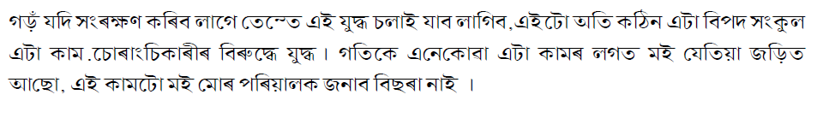
06:38
Organized crime syndicates control the poaching with superior weapons and big money – A kilo of horn sells for 10s of thousands of dollars in China and the Middle East.

06:52
Forest guards have a license to kill poachers on sight.

06:59
Uttam Saikia deals with them through other means. He has an extensive network of informants throughout the area. They are his eyes and ears, warning him about any threats to the Rhino.

07:17
UTTAM SAIKIA
I never answer the phone, I always call back. Because if anybody calls me I don’t want him to have to pay for the call, that’s why I always call back.

07:30
UTTAM SAIKIA
Hello Raju!

07:35
Mobile phone coverage is exceptionally good throughout Assam.

07:56
UTTAM SAIKIA
I am involved in anti poaching activities. I don’t have a gun but I have a mobile.
Poachers have guns but this is my weapon, it helps me a lot.
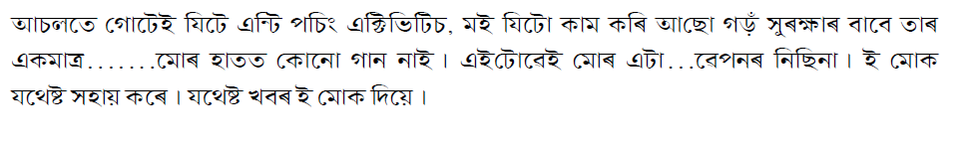
08:12
The real India meets Kaziranga National Park at
National Highway 37.

08:17
The road crosses the entire state of Assam and runs along the southern edge of the park.

08:23
When the Brahmaputra river floods the park, thousands of wild animals cross this road to get to higher ground.

08:31
Assam's famous tea plantations border the highway.
The colours and movement of traditional India are always close.

08:50
150 villages border Kaziranga. The people are mostly poor farmers with a few rice fields that yield just enough to buy food.
Fresh drinking water is still a problem.

09:07
And they life right next to one of the world’s richest arks of endangered and dangerous animals.

09:21
Rhinoceros can be seen right from National Highway 37.
They don’t often stray across the road.
But herds of elephants do, every night.

09:30
Kaziranga National Park is not the elephants’ permanent home. They are migratory animals. In winter they come to Kaziranga to eat the tall elephant grass.

09:50
But these elephants aren’t gathering to eat, one of their herd is fallen.

10:04
Anjun Talukdar is the head vet for the park’s animal rescue centre. Park staff have called him in to treat a 40 year old female.

10:24
ANJUN TALUKDAR
It looks to me it may have slipped from there and got stuck so we’ll try to help it get up.

10:34
It’s difficult to know if there’s anything else wrong with her. A grader will be brought in to help dig her out.

10:48
Rathin Barmin, is the director of the rescue centre.

10:54
He and Anjun have been caring for Kaziranga’s wildlife for the past decade. In and outside of the park.

11:08
ANJUN TALUKDAR
We‘re giving it some supporting treatment to help it recover what it has lost in the last 24 hours; It has been lying here and it didn’t have any feed or any drink. So we'll try to help it recover and we’ll get an excavator to dig it out and
get the elephant on its feet.

11:48
ANJUN TALUKDAR
Its just collapsed, it has collapsed.

11:50
RATHIM BARMIN
It has died. It has died.

12:01
RATHIM BARMIN
We tried.

12:20
ANJUN TALUKDAR
It’s sad to see such a beautiful animal dying so soon.

12:24
ANJUN TALUKDAR
Losing one elephant is quite a big loss.

12:32
At least 10 elephants a year die of natural causes inside the park.
But it is outside of the park when elephant herds come in contact with humans where the toll is highest

12:47
ANJUN TALUKDAR
We’re in a war in this area. We have so much conflict, and people's tolerance levels are low.
People don’t tolerate animals any more.

12:58
Loss of habitat outside Kaziranga National Park is causing the herds to raid rice fields, attack people, and demolish houses. As the human population increases, territorial disputes escalate.

13:13
ANJUN TALUKDAR
We’ve lost almost 30- elephants this year because of this conflict.

13:24
Raju Kutum works as an animal keeper at the wildlife rescue centre. He cares for orphaned elephants – victims of the people animal conflict around Kaziranga. He is on night duty, a 15 hour shift during which he demand feeds

the babies. A baby elephant will drink up to 12 litres of milk a day. The calf he is currently caring for is 4 months old. She was attacked by villagers after they killed her mother during a crop raid.

14:10
RAJU KUTUM
His forehead had been cut by someone. It’s a deep injury but the vet treated it. Now there’s no infection.
और ....वो हाथी को रेस्क्यू जब हुआ था... उसमे ये..ये पूरा कटा हुआ था |..ये...रेस्क्यू जब किया है.. तो उसमें पूरा कटा हुआ था | ..और ..इसलिए ही इसको यहाँ “....” रेस्क्यू कर के लेके आये...
सर इसका भी कुछ ऐसे ही....रेस्क्यू करके ही..इस्..इसको लेकर के आये |

14:27
The calf is out of immediate danger. She will soon leave Raju's care and move in with other orphans who don't need constant attention. One day she will be released into a protected area.

14:43
Raju was not always an animal lover

14:49
RAJU KUTUM
In my village we used to hurt all the wildlife. Then when this centre opened up the people in the village stopped the killing. I also stopped killing animals and realized the value of wildlife. I’ve come to realize that all animals are disappearing from this world. I tell other people in my village that we’re losing the animals.
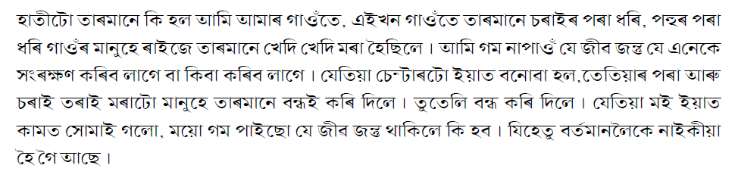
15:24
Close to midnight a new victim of the people animal conflict arrives.

15:30
Barely a month old, this little elephant was pulled out of a drain in a nearby tea plantation. For two days, tea workers tried to feed him bananas. But he’s too small to eat solid foods. Now, suffering from dehydration, the elephant has been brought in for care.

15:59
The tiny male’s red eyes are a sign that he badly needs fluids.

16:14
Another evening on the frontline of Kaziranga’s people animal conflict.

16:27
On the National Highway, and in surrounding rice fields, armed forest guards
try to keep the elephant herds that move in and out of the park, away from potential conflict.

16:40
ELEPHANT PATROLMAN
This fence was knocked down tonight, the herd just walked over it.

16:59
And in the morning – the elephants often leave a moonscape of damaged land behind. After constant trampling by an elephant herd, land becomes so degraded that it can never be planted again.

17:23
It’s 7 a.m. and Raju's shift is nearly over, but he’s been asked to keep working because there will be an attempt to reunite the orphan from the tea plantation with his herd.

17:53
RAJU KUTUM
It’s always better to reunite a baby elephant with its mother. That would make us happy too. And the calf will be happier with its mother instead of having to stay at the wildlife centre.
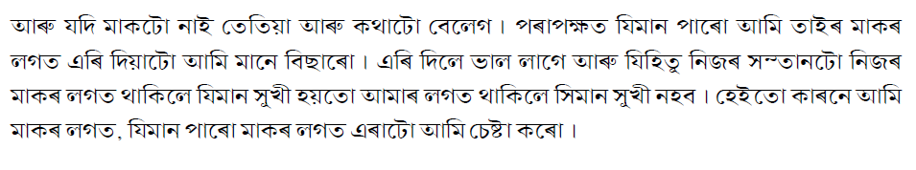
18:13
The baby was rescued from a drain like this. They are dug all around the tea plantations to deter the elephants. But finding the orphan’s herd in 600 hectares will not be easy. It needs information from the tea workers. Honorary wildlife warden Uttam Saikia is brought in to help.

18:32
UTTAM SAIKIA
Are the elephants ahead ? Can you find out?

18:38
Uttam was once a liaison officer for the tea workers here. They are still part of his extensive network of contacts - his eyes and ears outside the park.

18:51
UTTAM SAIKIA
They told me the herd is in the tea garden, it’s not so big, we’ll go ahead and see.
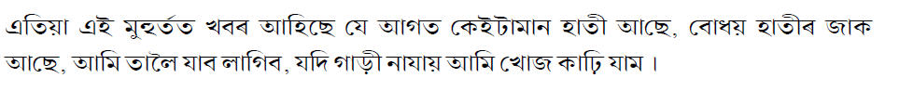
19:00
It is a small herd, 20 or more elephants. But there’s no guarantee that this is the orphan’s herd. Three groups of elephants frequent the area, using corridors that pass through the tea plantation leading to the park.

19:17
The baby is smeared with the herd’s dung. Even if this calf’s mother isn’t present, the familiar odour may lead one of the females in the herd to adopt the orphan.

19:30
Forest guards are present to protect onlookers, this is extremely dangerous work. Rescue centre director Rathim Barmin, and head vet Anjun Talukdar oversee the operation.

19:52
Part of the herd has broken away from the main group. At night they are fearless, but during the day they are extremely nervous.

20:03
They head towards a tea garden fence with the orphan in pursuit.

20:20
As the small group breaks through the fence, it’s clear they have no interest in the baby.

20:33
The orphan returns to the humans on its own. He will be taken back to the centre, cleaned up and fed.

21:00
Director Rathim Barmin begins the first of a number of reports on the animal.

21:06
RATHIM BARMIN
We can’t be 100% sure why this calf was left behind by the herd
The one theory we always presume is that it is not fit to move with the whole herd.

21:20
Raju will try to help the baby recover its fitness. The window of time to reunite is short. But they will try again. Until then, Raju heads home after a long day,

21:46
On the Brahmaputra River, Uttam Saikia is heading towards the Shapori sand Island in his family’s old river boat.

21:57
The sand banks and islands are constantly shifting due to the river’s strong currents.

22:05
The sand islands are strategically important in the fight against rhino poaching. All traffic across the Brahmaputra towards the Kaziranga wetlands can be observed from them.

22:19
People like buffalo herder Oikay Kutum, can be crucial informants. Today, forest guards on patrol have stopped for a meeting organized by Uttam to build trust between herders and officials. Uttam openly discusses new information in front of everyone present. He calls himself the air between the people and the officials.

22:50
UTTAM SAIKIA
From the poachers telephone numbers we can find out their location.
I had just one number and from this number I located a poacher at the Numaligarh telephone tower.
According to the information the poachers have a lot of arms they might have numbers of weapons.
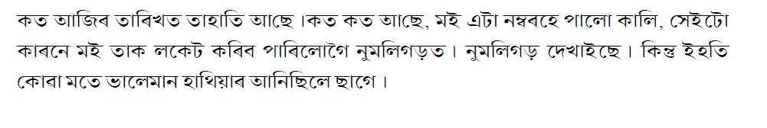
23:15
A poaching attempt seems imminent. It could result in the death of a one horned rhinoceros, a poacher, a guard or any combination of the three. The only thing for sure, is that it will happen at the worst possible time, after dark

23:31
Uttam takes his leave. With nightfall also on his mind, Oikay continues an important task. He’s making a shed out of dried elephant grass to protect a new addition to his cattle herd.

23:48
OIKAY KUTUM
I’m building a new shed. A pregnant cow will soon give birth and I fear that the baby will be affected by the cold at night.
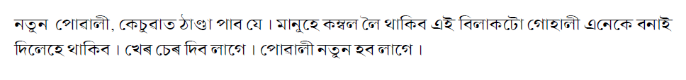
24:04
Oikay’s neighbours have gathered to help speed up the process.
The winter temperatures in Kaziranga drop close to freezing overnight. A new born would die if not sheltered.
Oikay wants to get his pregnant cow into the shed tonight.

24:22
But there is a problem, She seems to have gone missing.

24:31
OIKAY KUTUM
My pregnant cow isn’t with the herd.

24:50
OIKAY KUTUM
I have to go search for her. I might have to go into the reeds.
24:57
The reeds are where the tigers hide.

25:12
There are tiger footprints along the Brahmaputra, but they are weeks old.

25:18
The cow is nowhere to be found.

25:22
The forest guards head into the night on the lookout for poachers.

25:30
Uttam Saikia waves goodbye from his river boat.

25:38
And while Oikay wonders where his cow has gone, she makes her own way right to the door of his hut.
She’ll be safe tonight from the wild things of Kaziranga.

26:07
Not all of the animals of Kaziranga are dangerous.

26:15
Winter brings bar headed geese from Siberia, they've flown over the Himalayas to get to the Kaziranga wetlands.
Rare black-necked storks join the geese and ducks that come here to feed in abundant waterholes.

26:46
The elephant herds that visit Kaziranga also have plenty of food inside the park, but by nature they migrate. They use the same pathways they have always used - even if those tracks now pass through highways and villages.

27:03
This is the village of Punbari. It's right next to a forest. The people who live here were relocated 40 years ago after floods washed their land into the

Brahmaputra. When they arrived, instead of finding work in towns like the government expected them to, they cut down some of the forest, planted crops and had families. They didn’t know they were right on the edge of an elephant corridor.
This is where Raju Kutum the orphan elephant carer grew up. He still lives
here.

27:47
His house is a simple mud hut shared with his wife Urmila and their three children. They are tribal Mishing people from the Brahmaputra floodplains. The family have lost their house and possessions to elephants in the past. And people in Punbari have died in elephant attacks.

28:23
RAJU KUTUM
This is an elephant prone area. Throughout the year elephants come to the village. Our village is right on the edge of Kaziranga National Park bordering the remaining forest.
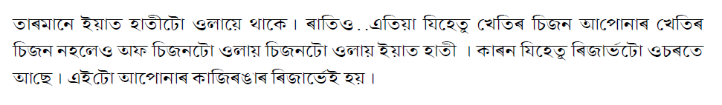
28:40
Raju’s father was among those who cut down the forest to plant fields. But Raju is now trying to help his children understand the ramifications of those actions.

28:54
His eldest daughter Pinky is 17.

29:03
PINKY KUTUM (17)
My Father tells us stories about his work as an elephant keeper and I am proud of him. He says elephants never harm him but he always advises us to be careful at night.
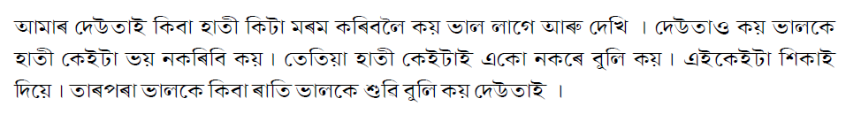
29:29
Raju’s family have come to terms with the constant elephant threat.

29:35
URMILA KUTUM
I’m not afraid when elephants come. Sometimes they come and eat the rice plants in the paddy fields, but that’s the way things are.
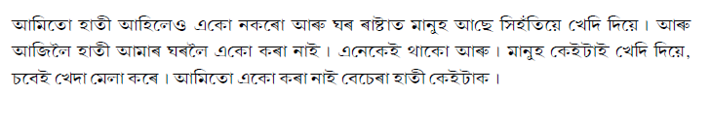
29:52
Neither Raju nor his wife Urmila have any formal education. And before Raju started working at the wildlife rescue centre, they could hardly afford to feed themselves.

30:11
RAJU KUTUM
My dream is to help my children become well qualified. Perhaps they can study animal behavior. There are no guarantees for the future but my wife and I are trying our best to give them the best possible education. I want to help them learn whatever they want to learn.
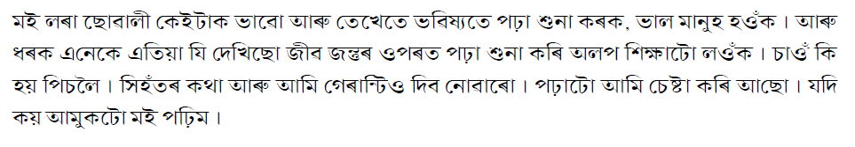
30:34
When Raju is on night shift looking after the elephant orphans, his family have instructions about what to do if the elephant herd comes. He also trusts that his family is protected by the good karma he has earned.

30:49
RAJU KUTUM
Since I look after baby elephants, I think God or the elephant god Ganesh will protect my family. I tell the family to be alert at night and if anything happens I’ll come immediately.
And never tease the elephants.
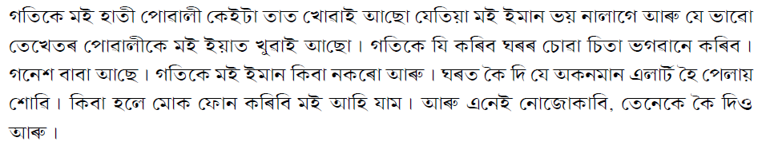
31:16
But when the elephants start to call everyone gets nervous.

31:25
RAJU KUTUM
Where is the elephant!
Is it near the Bamboo?
Oi Tufan!
Which way? Have they gone?
Through the tea garden?
Okay - let them go!
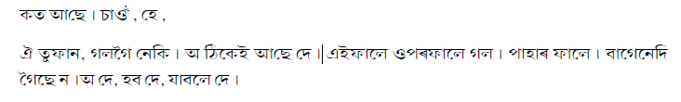

31:58
RAJU KUTUM
Since I started work with elephants I tell people not to kill them. If elephants are destroying your crops it’s better to scare them away than to kill them.
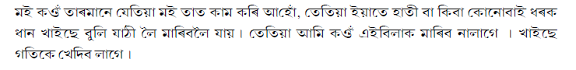
32:11
Punbari residents have special neighbourhood elephant watch groups. They use fire and noise to deter the animals.

32:22
But the danger tonight isn’t outside the park, it’s inside the park.

32:47
Uttam Saikia is on his way to a crime scene.

32:53
UTTAM SAIKIA
Two days ago I got a phone call telling me that a group of poachers was inside the park, I was also told the approximate location, so I informed the park director.
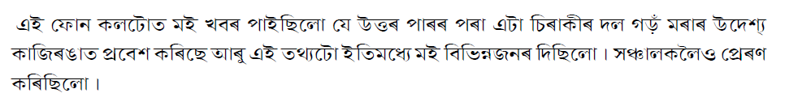

33:09
UTTAM SAIKIA
The information was acted upon – forest guards were alerted. They organized an ambush in the area. As soon as they started the operation, they encountered gun fire from the poachers.


33:34
UTTAM SAIKIA
The outcome is that in the Western part of Kaziranga – in between two anti poaching camps, this rhino has been killed and its horn removed.

33:49
Vet Anjun Tadulkar assists in the forensics.

33:57
ANJUN TADULKAR
These are ak 47 cartridges and these ak 41. We found 4 used cartridges and two live ones.
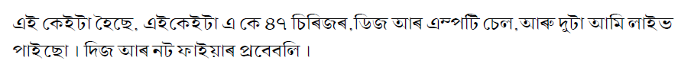
34:15
UTTAM SAIKIA
The poachers are one step ahead of the forest guards. The guards use old .303 and .315 rifles, which are not enough against AK-47 rifle. It depresses the guards.

34:38
A number of clues are scattered around the site including a machete and a cloth.

34:46
A specially trained tracker dog is brought in.

35:06
By the end of the day the dog will lead police and forest guards to the house of a Mr Sing Bey. He will be arrested, but he will only be one of many who were involved in this horrific crime.

35:28
Organized crime agents target poor local village people. They offer them cash loans. When it comes time to pay back and they don’t have the money, they and their families are threatened with death if they don’t lead poachers to the
rhinos.
And for locals, the rhinos are easy to find.
The animals go to the toilet in the same place. They do it to leave scent messages to one another. But it’s a red flag to their killers.

35:58
UTTAM SAIKIA
If the international ringleaders are not caught, it will be impossible to stop poaching in Kaziranga.
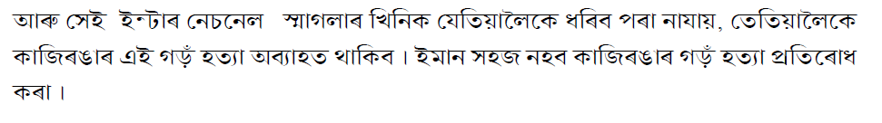
36:06
Over 25 rhinos are killed each year in Kaziranga and at least 3 poaching attempts are thwarted every month with the help of intelligence from Uttam and his informants.

36:18
UTTAM SAIKIA
Kaziranga can only survive with the help of local people. Without them the authorities are helpless. Kaziranga National Park belongs to the people.


36:34
Uttam will continue to be the bridge between local people and authorities. Fighting poachers with his mobile phone and a lot of courage.

36:51
At the wildlife rescue centre, Raju is preparing the baby elephant for another attempt to reunite him with the herd. This will be the final try.

37:16
A herd is in the tea garden again. The release will happen at night when the elephants are more secure. It’s at night that they do most of their moving about in search of food.

37:51
The elephants have gone completely quiet.

38:22
It looks as if the baby has been recognized and it may even be following the herd through the low scrub. But it’s too dangerous for the rescue team to wait around and find out.

38:44
From a distance at least, there’s no sign of the one month old orphan.

38:54
The team will return at dawn to check if the baby has gone.

39:10
At the wildlife rescue centre, director Rathim Barmin writes his last report on the orphan’s release.

39:17
RATHIM BARMIN
This morning we went to the site again to check if the calf had gone back to the herd or not.
We searched for the herd for about one and a half hours and during that time we heard elephant calf sounds.
We could track the sound and fortunately or unfortunately we found the calf alone, left behind by the herd again.

39:46
RATHIM BARMIN
Our first option is always to try to reunite, but if we fail, then we’ll do the hand raising here. In this case we tried our level best to reunite first, but we failed. But we’ll hand raise and reunite later. That’s what we’ll do.

40:07
Until this little baby stops needing milk, Raju will be his mother.

40:16
RAJU KUTUM
When I first started working at the rescue centre and began to look after orphan elephants I learned how to read their behaviour. And I discovered that a young elephant calf can’t be away from its mother. This little male was just one month old when he fell in a drain. We rescued him. When he grows up I’ll feel good about it. I’m helping to save an endangered species.

40:48
In two years the baby will join other orphans being trained to fend for themselves. Then, when he is ready, he will be released into a reserve away from human settlements. There the little elephant who lost his mother in a tea garden will be introduced to a new, wild herd.

41:12
On Shapori Island in the Brahmaputra River, Oikay Kutum’s cow has finally given birth.

41:23
OIKAY KUTUM
One more baby in my cow shed. I am really happy.
I’m very happy for this newborn baby. It’s a female calf, and that’s also very good.
Sometimes it’s a critical delivery but this one was born safely.
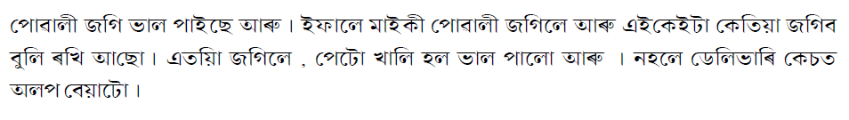

41:51
Oikay invites a priest who also lives on Shapori to perform the pooja, to wish the calf and mother well and protect them from tigers and wild water buffaloes. The baby was born on a Friday. Female, and Friday, for cattle at least, are auspicious signs.

42:13
For Oikay Katumb, this is the cycle of life, a mix of hardship, danger and joy.

42:21
OIKAY KUTUM
And this is the way of our life.
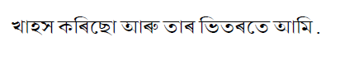
42:28
When the mighty Brahmaputra river floods each year Oikay and his cattle leave the sand island.

42:37
The floods will clean the wetlands, and replenish the rich nutrients that make Kaziranga a refuge for some of Asia’s rarest creatures.

42:47
Kaziranga is a world heritage site, but its future is in the hands of its people.

